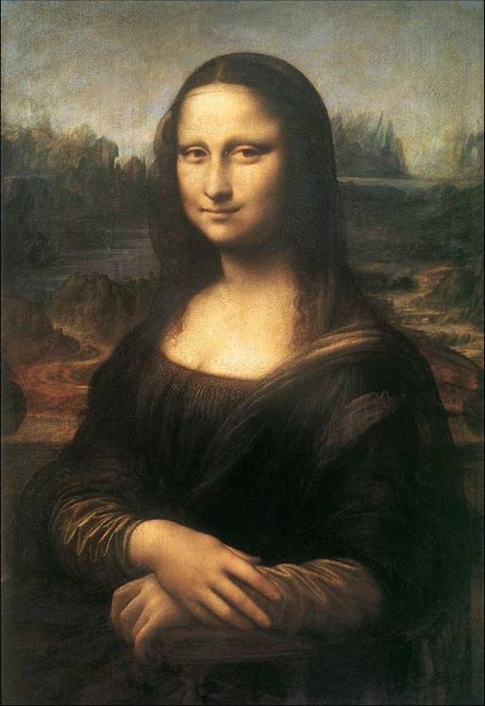
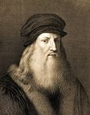
Leonardo Da Vinci
Leonardo Da Vinci (1452-1519) 1)__________ (be) an incredible man. He 2)________ (work) as an artist, architect, mathematician and scientist. He also 3) __ ______ (work) as a military engineer and 4)______ (be) a good musician. Leonardo 5)_______ (be) born in Vinci near Florence. He 6________ (like) school but he 7)_______ (hate) Latin. In 1466, Leonardo’s family 8_______ (move) to Florence and he 9)_______(finish) school. In 1482, he 10)________ (leave) Florence for Milan and 11)_________ (start) to work for Duke of Milan. He
12) _________ (want) to build a new town and 13) _______ (design) many buildings for the Duke, but the Duke 14)________ (refuse). He also 15)_______ (study) mathematics. His drawing of the Anatomy of a Man
16) _________(show) him to be a great biologist. In Milan Leonardo Da Vinci 17)_________ (make) a lot of his paintings and drawings but he 18)_________ (lose) most of them. In 1502, he 19)_________ (return) to Florence and 20) _________ (paint) the Mona Lisa. He 21) _______ (carry) his painting with him when he 22)__________ (travel). From 1514 to 1516, he 23)_______ (live) in Rome and 24)________ (make) his scientific experiments. He 25)_______ (take) interest in acoustics, astronomy, mechanics, mapmaking, optics, weapons and other branches of science.
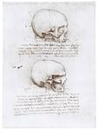
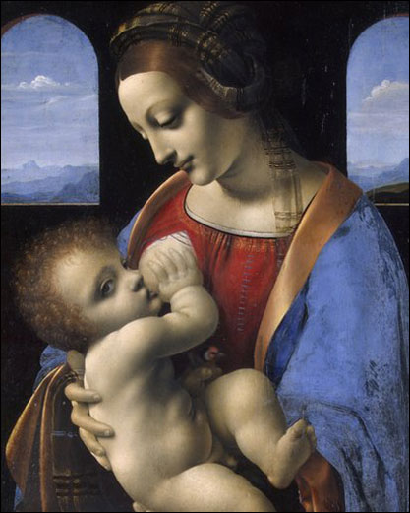
Leonardo Da Vinci was a unique person. He 26)______(write) from right to left – people 27) _______ (need) a mirror to read his writings. He also 28) _______(can) write different sentences with his right and left hands at the same time. He 29) _________ (invent) scissors and 30)_________(make) drawings for a tank, a helicopter and a submarine. His scientific inventions 31)______ (be) a hundred years before his time.
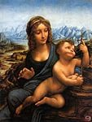
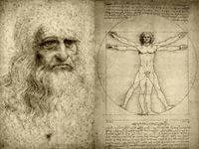
Leonardo Da Vinci 32)______ (die) in France in 1519.
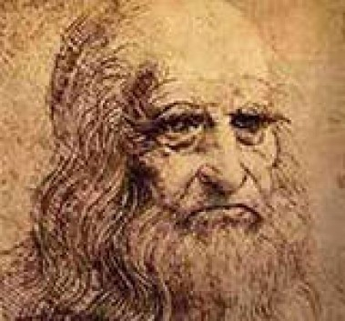
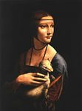
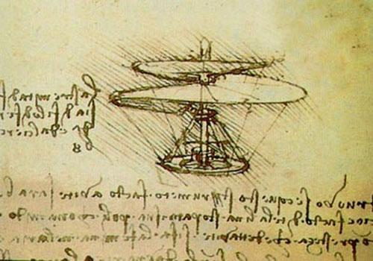
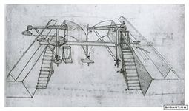
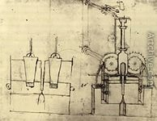
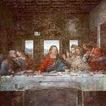
ANSWERS
- was
- worked
- worked
- was
- was
- liked
- hated
- moved
- finished
- left
- started
- wanted
- designed
- refused
- studied
- showed
- made
- lost
- returned
- painted
- carried
- travelled
- lived
- made
- took
- wrote
- needed
- could
- invented
- made
- were
- died

