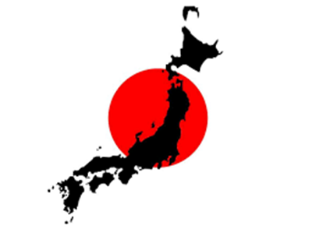
Activity 1: School lunch in Japan
- While watching the video, fill in the missing information in the sentences below.
Δραστηριότητα 1: School lunch in Japan
Ενώ παρακολουθείς το video, συμπλήρωσε τις πληροφορίες που λείπουν στις προτάσεις παρακάτω.
- In Yui’s bag there are:
- 1.
- 2.
- 3.
- 4.
- 5.
- In Yui’s class there are…. Pupils.
- Today’s menu has…..
- 1.
- 2.
- 3.
- After putting on their masks, pupils put…………………in their hand
- s.
- After lunch, pupils…………

