PRIVATE VIEW | ART HISTORY
El Greco: A modern artist in the 16th Century
Share using Email

Share on Twitter
Share on FacebookShare on Linkedin

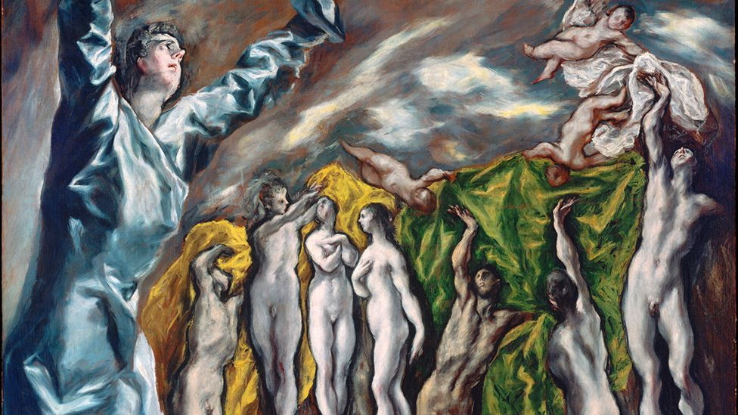
By Jason Farago26th August 2014
This year is the 400th anniversary of El Greco’s death but his works can feel shockingly modern. Jason Farago examines how his works influenced Manet, Cézanne, Picasso and Pollock.
F
Few artists stick out from the standard tale of western painting more pointedly than El Greco, the great outlier of the late 16th Century. Deeply religious, passionately single-minded, he merged the art traditions of three different countries and found his own unsettling painterly language, one that took a very long time to find its most receptive audience. Flip through the pages of a textbook or wander through the permanent collection of a major museum and you can sometimes fool yourself that art history is a clear and predictable progression, one style and one century inevitably giving way to the next. But art history, we know, isn’t nearly so simple, and El Greco, like few other painters, gives the great delight of seeing that story disrupted and contradicted.
El Greco and Modern Painting, a major exhibition now on view at the Museo Nacional del Prado in Madrid, demonstrates the influence of the Spanish-Greek artist on figures as divergent as Manet and Picasso, Beckmann and Pollock. It also, inevitably, suggests that El Greco was in some sense ‘modern’ himself. Wrenched out of time, El Greco speaks more easily to secular museumgoers than many religious artists of the 16th century. We can look at his altarpieces and his portraits as bold experiments with form and colour, or see in his torqued figures the presentiment of abstraction. Yet looking at El Greco’s influence on modern artists offers a chance to see not only what is timeless in the artist’s work, but also what’s not. And putting El Greco alongside the moderns can help us see art history as more than just a series of dots on a line, but a multi-directional conversation that upsets time itself.
For another age?
El Greco – or Domenikos Theotokopoulos, as he was born – was born in 1541 in Crete, which was then a colony of the Most Serene Republic of Venice, the reigning bosses of the Mediterranean. After training as an icon painter, he moved to Venice and later to Rome, yet despite the booming market for religious painting in the midst of the Counter-Reformation, El Greco’s career took some time to get going. It wasn’t until the late 1570s, when he settled in Toledo, Spain, that the artist began developing both the contacts that would sustain his career, as well as the groundbreaking, disturbing, unprecedented style that would characterise his mature art.
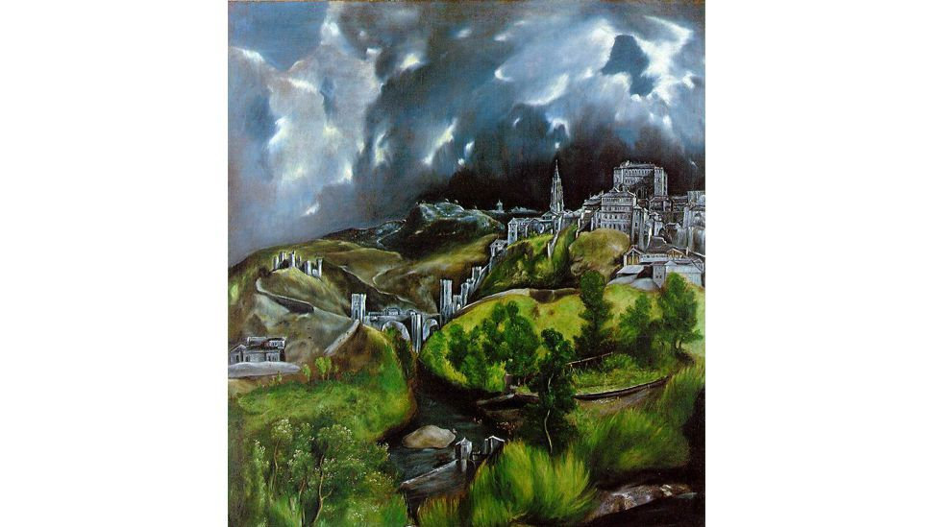
View of Toledo by El Greco (Metropolitan Museum of Art, New York)
In Venice, the young El Greco produced composed, vibrant tableaux in the manner of Titian (whom he may have worked for at one point; the historical record isn’t clear), and had he stayed there he might be remembered today as a talented but not extraordinary painter of the late Renaissance. But in Spain his art became more penetrating, more Mannerist, and much more idiosyncratic. Figures, especially faces, became elongated and corkscrewed, almost post-human. Striking, at times reckless use of chiaroscuro makes pink and blue robes burst from the canvas. Rather than anatomical verisimilitude, El Greco’s Spanish-period paintings strove for religious intensity and sensual potency, and he was happy to sacrifice naturalism to get there. Looking today at his creepy eschatological Vision of Saint John, from 1608–1614, it’s hard to imagine how the conservative religious community of Toledo would have understood its anguished gray sky, its unorthodox use of scale and its transformation of holy figures into stark, twisting panes of colour. You can only conclude that El Greco knew his audience was not just the folks in town, but past masters, future admirers and probably divine observers too.
El Greco was not a lone wolf or a hermit. He was a shrewd businessman and he had supporters, though nothing on the level of such hustling artist-politicians as Titian or Rubens. After his death in 1614, however, at the dawning of the Baroque era, El Greco fell from favour. His idiosyncratic, sometimes disturbing style, with its bold rejection of naturalism – the very thing that makes him seem so fresh today – marked him in the 17th and 18th centuries as at best a minor painter on an off-ramp of art history, and at worst a madman. But El Greco wasn’t mad at all. He was single-minded, extravagant, stubborn perhaps and willing to wait for fame: for centuries, if needed

