ΓΛΩΣΣΑ Α’ ΔΗΜΟΤΙΚΟΥ
Το γράμμα Ν,ν 
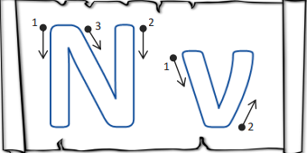
Γράψε κι εσύ το γραμματάκι Ν,ν !
Ν, ν !

………………………………………………………………………………………………………………………………………………………………………………………………………………………………………………………………………………………………………………………………………………………………………………………………………………………………………………………………………………………………………………………………………………………………………………………………………………………………………………………………………………………………………………………………………………………………………………………………………………………………………………………………………………………………………………………………………………………………………………………………………………………………………………………………………………………………………………………………………………………………………………………………………………………………………………………………………………………………………………………………………………………………………………………………………………………………………………………………………………………………………………………………………………………………………………………………………………………………………………
